Final version of pictures

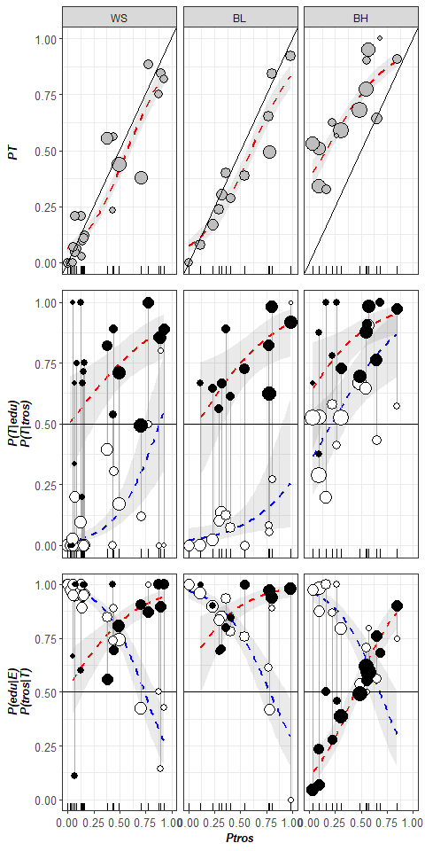

Figure ++. Variation of PT, P(T|tros), P(E|edu), P(tros|T), P(edu|E) as functions of Ptros in the White Sea (WS), brackish Barents Sea (BL) and saline Barents Sea (BH). Points - empirical estimates, size is proportional to sample sizes. Lines – regression model predictions, grey filling – 95% confidence intervals of regressions. (A) Proportions of T-morphotypes (PT) (Model 1). (B). Proportions of T-morphotypes among *M. trossulus* (filled points) and *M. edulis* (empty points) (Model 2). (C) Frequencies of *M. trossulus* among T-morphotypes (filled points) and of *M. edulis* among E-morphotypes (Model 4). Vertical lines on B and C connect subsamples of *M. trossulus* and *M. edulis* from the same samples.

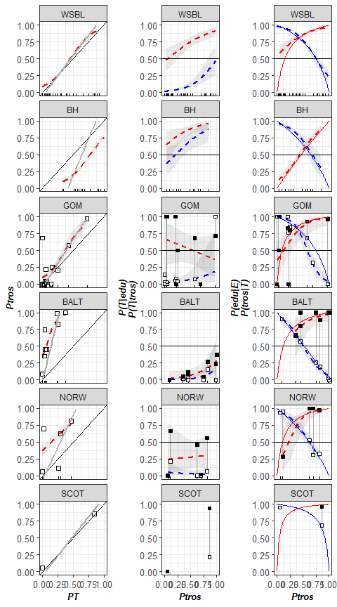

Figure ++. Predictive power of morphotype test in different regions. (A) Dependence of Ptros on proportion of T-morphotype mussels. Dotted line is empirical regression line (Model 4). Solid gray line - prediction accordingly to Eq. 3. Solid black lines represent Y=X dependence. (B) Probability to find a mussel with T-morphotype among *M.edulis* and *M.trossulus*. Dotted lines correspond to regression Model 5. Black squares - *M.trossulus*, white - *M.edulis*. (C) Probability of correct species identification by morphotype-test. Dotted lines are empirical regression lines (Model 6). Sold red line - prediction by Eq.1, Solid blue line - prediction by Eq.2. Shedded areas around regression lines represent 95% CI. In all cases dots represent observed proportons in samples.

